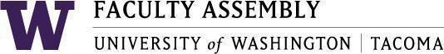

Agenda
Faculty Affairs Committee Meeting
January 13, 2025 / 12:30pm-1:20 p.m.
Zoom

- Recording Permissions/Consent [2 mins]
- AI Discussion with Dr. Richard S. Lewis [50 mins]

Join Zoom Meeting
https://washington.zoom.us/j/98908537183
Meeting ID: 989 0853 7183
Dial by your location
• +1 253 215 8782 US (Tacoma)
• +1 206 337 9723 US (Seattle)

