Faculty Assembly Executive Council (EC)
Meeting Minutes
Friday, 12/6/2024, 1:00 p.m. – 3:00 p.m.
Zoom

Present: Chancellor Sheila Edwards Lange, EVCAA Andy Harris, Chair Anne Taufen, Vice Chair Andrea Hill, Past Chair Huatong Sun, APCC Chair Julie Masura, APT Chair Bryan Goda, Monika Sobolewska, Jim West, Barb Toews, Robin Evans-Agnew, Gary Viers, Jenny Xiao, Sushil Oswal, Margaret Griesse, Ander Erickson. Excused: FAC Chair Ken Cruz, Emily Thuma, Kurt Hatch, Zhiquan (Andy) Shu, Bara Safarova, Greg Noronha, Alex Miller, Erika Bailey. Guests: Susan Wagshul-Golden (Director for Emergency Preparedness and Campus Safety), Sylvia James (Vice Chancellor for Finance & Administration) Program Coordinator: Andrew Seibert

- Opening:
  - Land Acknowledgement, Consent to Agenda, Meeting Minutes, Permission to Record, Approval of Meeting Minutes from 11/25/2024.
    - The Chair read the Land Acknowledgement. The agenda was consented as amended by the Executive Council. Permissions to record for minutes purposes only were granted with no objections. The Executive Council minutes for November 25th were tabled due to no quorum and will be reviewed at the January 10, 2025, Executive Council meeting.

- Chair’s Report
  - Budget Update and Unit-Level Adjustment
    - The Faculty Assembly Executive Council has been working with the Executive Vice Chancellor for Academic Affairs and the Tacoma campus Director for Planning & Budget for Academic Affairs for the locally funded unit level adjustment which is based on a model devised in 2023 by a faculty-led SIAS taskforce.
      - The process does not require local EFC Chairs to submit their own models currently. EFC engagement on the application of the proposed model will enable units to further refine for any subsequent adjustment process.
    - The UW Tacoma Fiscal Services held their budget kickoff last week and faculty can learn more and watch the zoom recording. Please review and share with units; FA will continue to engage this process.
    - UW Senate updates; Tri-Campus Policy (EO’s and Faculty Code alignment)’SEC has forwarded multiple Class A and Class B legislation proposals, and Class C resolutions for different stages of review and vote to the Faculty Senate. These can be found on the UW Senate Pending Legislation website, with the protocol for electing a UW Faculty Regent currently out for a full vote. Please contact your unit level representatives for more information, including FAQ’s regarding changes to the definition of teaching excellence in the Faculty Code developed through the FCTL.
    - Areas of tri-campus policy include apportionment of Senators and addressing functional discrepancies between the Faculty Code and Executive Orders. These are being handled by the Faculty Council on Faculty Affairs (FCFA) and the Faculty Council on Tri-Campus Policy (FCTCP), respectively.
  - Winter Retreat
    - Two potential workshop plans will be presented for EC members’ review and discussion, later in the agenda. The design of the Winter Retreat is focused on increasing practical outcomes and participation by EFC chairs. Goals:
      - improve communication and cooperation on our shared campus and unit-level initiatives
      - strengthen shared ecosystem of faculty governance across the campus and university.
- Chancellor’s Update to Executive Council
  - Chancellor Lange made her quarterly report to the Executive Council Representatives
    - Chancellor Lange, along with Co-Chairs of the Budget Committee are looking at ways to be more transparent with budgeting.
      - Enhanced monitoring is scheduled to be completed at the end of this academic year. Although enhanced monitoring will be completed, it does not put UW Tacoma out of the woods at this time, as budget is based on enrollment. Budget continues to be monitored.
      - The Office of Planning and Budgeting will be in contact with our campus in January to find ways to monitor our budget more closely during the hiring freeze that was enacted by Governor Jay Inslee. Although this typically does not affect higher education, and mostly state agencies, it is recommended to have a plan moving forward.
    - There were events to get feedback from Faculty, Staff, Students, and the community regarding the future of the campus and the campus master plan. For those who were not able to attend, there is still an opportunity to fill out an online survey which can be found here.
    - Chancellor Lange remains positive around enrollment, as there has been recruiting of new students, along with retaining our current students. Approximately 340 more students are expected Winter 2024 versus Winter 2023. The campus is still working with the consultant with the Strategic Enrollment Plan, and enrollment.
    - The Senior Leadership Team is planning for the upcoming federal administration. The Provost Leadership team, along with our EVCAA will be looking into the proposed changes federally.
    - A Title II finding was made against University of California, Berkley which requires universal access for people with disabilities. This involved electronic materials such as websites and records. UW will be launching action teams working with UW Seattle, UW Bothell, UW Tacoma, and UW Medicine. UW Tacoma does have local personnel that will be creating a resource page. More to come in the future.
    - Capital Projects/Funding requests
      - Housing and Dining projects have been approved and is moving forward.
      - Funding for Health Sciences building request has been made for a future project.
      - Funding to repair the electrical grid is on for legislative ask in January 2025.
      - Compensation requests to fully fund cost of living requests was requested. This is currently fully funded in the Community and Technical Colleges around the state and is currently funded at a 60/40 split for universities.
      - Request for funding on Cybersecurity and Emergency Preparedness.
    - Campaigning planning has identified 6 key priorities that are the foundational funding asks. They are Climate, AI, Health/Behavioral Health, Democracy, Equity and Belonging, and Student Success. Locally, UW Tacoma will be reviewing what fits into these priorities and add statements to the campaign and ask for.
  - Discussion ensued on these updates:
    - Funding will be made available from the President/Provost office on accessibility needs for Faculty to comply with Title II. IT and HR are working on these currently.

- Standing Committee Chairs’ Reports
  - Standing Committee Reports were sent out to the Executive Council regarding updates from the Academic Policy & Curriculum Committee; Appointment, Promotion, and Tenure Committee; and the Faculty Affairs Committee. APCC and APT Chairs read their updates. The Program Coordinator to Faculty Assembly read the Faculty Affairs Committee on behalf of the Faculty Affairs Committee Chair. Please see Appendix A for the reports, and a flyer for four upcoming curriculum events.
  - Around the Table
    - A faculty member raised questions about the unit-level adjustment model and its definition of compression. The response focused on the limitations of a locally funded unit adjustment and the effort to devise a transparent, equitable, and principled framework. This will not address salary compression for all faculty; however, units can explore additional steps to request and allocate funds to further ameliorate pay disparities that may exist and persist at the unit level and vary by discipline.

- Campus Safety Update
  - Susan Wagshul-Golden updated the Executive council on the latest work on the Safety and Advisory Committee.
    - 2024 highlights
      - Partnering with student government (ASUWT) to have representation on the advisory committee. Hearing concerns from students such as parking and nighttime concerns.
      - Reorganization of both campus safety and parking & Transportation.
      - Partnering with representatives from the City of Tacoma to get lighting improvement uphill.
      - The committee met this month to look at best practices on preventing workplace violence. Discussing recommendation and present to Sally Clark and Gillian Wickwire.
      - Emergency procedures in classrooms and public spaces.
      - Card reader updates for classes.
      - Emergency Preparedness Manager hired, working with Bothell’s manager and Seattle’s Deputy Director.
    - Discussion ensued
      - The Co-Chair of 2023-2024 Campus Safety Committee requested ongoing support for this work by EC, including prioritization and implementation of recommendations of this group.
  - Sylvia James, Vice Chancellor for Finance & Administration updated the Executive Council on requested administrative commitments, such as floor wardens and advancements in emergency procedures for the Tacoma Campus. The following are highlights:
    - The Campus Community Safety Advisory Committee has transitioned from Academic Affairs over to Finance and Administration and with operationalization, will include Faculty, Staff, and Students. Pieces such as bylaws and goals will also be added to keep this committee thriving. Vice Chancellor for Finance and Administration would like to see faculty that have interest in safety volunteer.
    - As the reorganization of Campus safety and parking and transportation started, there is reorganization around facilities and planning (such as space planning, master planning, etc.) to review the needs of the campus such as floor wardens and would liaise with the Emergency Preparedness Manager.
      - Cross training of Campus Safety Officers and custodial staff is underway to work together.
    - Plans to have more ADA compliant options for the campus such as digitize signs (strobe, read out) and evacuation chairs for people with disabilities. This is one of two proposals, along with the congressional earmark request. This is a 1.75-million-dollar request where $200,000 for the ADA compliant options.
    - Finance and Administration has met with Pierce Transit and will be increasing stops to every 15 minutes on campus from 30 minutes.
      - Pierce Transit has committed to finding funding to install larger stalls for people and solar lights.
    - ASUWT voted to broaden the usage of the MOU on UPASS to have additional campus safety officers or guards to patrol parking lots and transit locations.
    - Discussion ensued on the updates
      - The University at-large is looking at continuity and operations planning and standardizing it.
      - The Emergency Preparedness Manager will work with all units.
      - Faculty noted that the administration response to safety concerns continues to prioritize physical and technical upgrades, while leaving other forms of relational safety, privacy and informed consent, and shared cultural safety concerns relatively unaddressed.
      - Faculty noted that there may be opportunities to broaden the $1.74 million federal grant to include areas of inquiry, teaching and knowledge production to benefit various fields on campus, for instance from Social Determinants of Health (SDOH) and diversity, equity, and inclusion (DEI) research perspectives.
      - The faculty suggested that EC may want to consider a more permanent role and body to contribute to constructively framing safety investment from the ecosystem-based, four-pronged cloverleaf model developed by the 2023-2024 task force.

- Faculty Assembly Winter Retreat Options

  - The Chair of Faculty Assembly presented two preliminary designs for the Winter Retreat workshops. Option A provides a unitary model where all participants attend a sequence of group workshops, together; Option B provides a shared workshop on workload equity reporting, followed by separate workshops from which attendees may choose:
    - § Using data to strengthen academic planning
    - § Implementing and co-learning with salary adjustment model
    - § Engaging in UWT and tri-campus policy opportunities

  - In both Options, Faculty Affairs Committee Past Chair Sharon Laing will review the Workload Equity reporting that EFCs are expected to conduct this year.
    - DEI councils are initiating a workload equity evaluation taskforce that is expected to deliver recommended practices for tracking and reporting on this, across the university, in the next year.
    - It is important that we implement the model that we ourselves developed through faculty governance and inclusive, collaborative process on this campus, so that UWT units are following our own policy, rather than having it imposed on us through UWS.
  - The goal of the Winter Retreat workshop is practical, substantive outcomes for attendees, EC reps and EFC Chairs
    - Members were asked to consider both the format as well as the content of proposed workshop models, keeping in mind the following:
      - What is the highest priority for faculty representatives, right now?
      - What will draw willing participation from unit-level EFCs and curriculum committees?
      - Are there topics that EC members would like to see addressed, that are not part of the options presented?
  - After discussion, EC members recommended Option B with a shared focus on Faculty Workload, followed by a self-selected workshop on the topics noted above.
  - Plans to finalize and circulate the FA Winter Retreat invitation and agenda should include the following:
    - EFC Chairs strongly encouraged to attend with specific outcomes emphasized, and their utility for unit-level needs and milestones
    - EC reps to identify, invite, and promote to unit-level colleagues, beyond email lists and campus-wide notifications
    - Tri-campus policy proposals from FCTCP to be available for workshop as well as possible changes for a more targeted UWT committee structure within FA
    - Recommendation to provide alternative options for Robert Rules refresher and FA Handbook review, to conserve and capitalize on faculty representatives in-person gatherings. Suggestion to include faculty-based Safety Planning to a future retreat agenda

- Adjournment
- The Chair thanked all presents for an excellent and productive term and wished everyone a peaceful and safe holiday season. The meeting was adjourned at 2:50 p.m.
  - Next Executive Council Meeting: January 10, 2025, GWP 320/Zoom

Appendix A: Standing Committee Reports

EC – APCC Updates
Proposal Type | September | October | November | December | Total
Modify Program | 1 |  | 1 | 1 | 3
New Program |  |  |  | 1 | 1
Modify Course | 26 | 4 | 1 | 1 | 32
New Course | 2 | 2 | 2 | 3 | 9
Graduation Petition |  |  | 1 | 1 | 2

Proposal | Presently | Next Step
MS Mechanical Engineering | Proposal development | Stakeholders & Council of Deans Review
BS Statistics and Data Science | Proposal development | Stakeholders and Council of Deans Review
BA Interdisciplinary Visual and Performing Arts | Entering in UWCM | EVCAA Review
DNPAP | Partnering with UWS | Awaiting update from SNHCL – Tri-campus Priority
MS Environmental Science | Proposal development | Stakeholders and Council of Deans Review
MS Civil Engineering | PNOI Council of Deans Review | PNOI APCC Review
SET – AI Graduate & Certificate | Idea Stage | PNOI Development
SIAS – World Language Graduate Requirement | Process Development – PNOI Review | PNOI Development

20241206 EC Meeting
- See table updates above.
- APCC is hosting 4 workshops in winter on curriculum review – Sail Through Curriculum Review. For more information: https://bit.ly/SailThroughCR
  - Faculty & staff
  - New and modification
- Details from the agendas & minutes can be found here: https://www.tacoma.uw.edu/facultyassembly/academic-policy-and-curriculum-committee

20241120 EC Meeting
- See table updates above.
- Working on process for World Language graduation requirement for SIAS.
- University Committee of General Education - Looking for faculty to serve on the Social Science board (NO UWT representatives). Vacancies also on Diversity, Reasoning, and Writing Boards at the tri-campus level.
- Need to do work on writing, distance learning, and committee charges.
- APCC is hosting 4 workshops in winter on curriculum review – Sail Through Curriculum Review. For more information: https://bit.ly/SailThroughCR
- Details from the agendas & minutes can be found here: https://www.tacoma.uw.edu/facultyassembly/academic-policy-and-curriculum-committee

2024113 EC Meeting
- Since the September, APCC has reviewed 2 program change proposals, 6 new courses, 27 course changes, and 1 graduation petition.
- We continue to drive the Academic Plan in partnership with Tammy Jez from the EVCAA Office.
Updates for new programs on campus include:
- MSME – Proposal Development. Next will be stakeholders & Council of Deans review.
- BSSDS – Proposal Development. Next will be stakeholders & Council of Deans review.
- BAIVPA – Stakeholders & Council of Deans Review Complete. Next will be APCC review.
- DNPAP – Partnering with UWS. Awaiting updated from SNHCL
- MSES – Proposal Development. Next will be stakeholders & Council of Deans review.
- MSCE – PNOI Stakeholders Review Complete. Next will be development of budget with Dustin Atchley from EVCAA Office.
Upcoming major program additions/changes:
- Graduate Program in AI
- Additional of Cohort to Graduate Ed Program (probably no need for curricular review)
- School of Social Work & Criminal Justice Updating
- SIAS looking to add world language requirement for graduation.
- Presented committee with charge letter. Need to work with leadership to develop and action plan to meet the policy creation requests.
Details from the agendas & minutes can be found here: https://www.tacoma.uw.edu/facultyassembly/academic-policy-and-curriculum

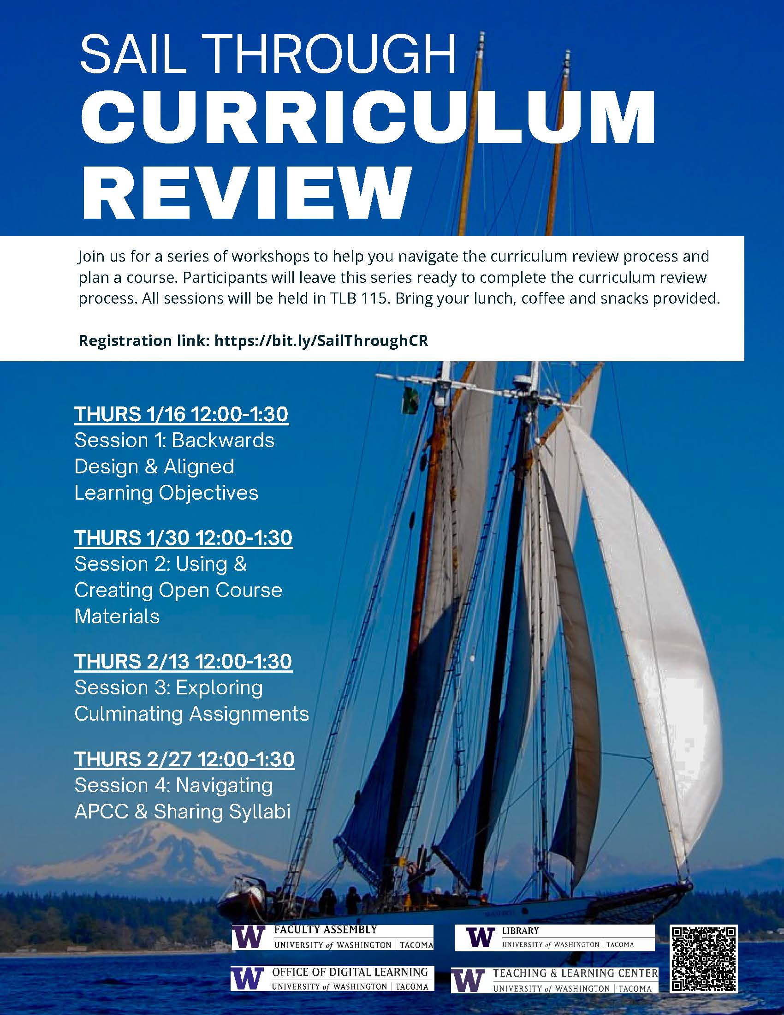

APT Committee Report December 6, 2024
- All 10 Mandatory Files reports are completed and signed.
- Briefing Andy on the Mandatory files on December 13th.
- All 14 Non-Mandatory Files are upload, ready for Committee Review
- Discussion meetings will be Jan 13th and 15th.

Faculty Affairs Committee (FAC) Updates
12/6/24

Ad Hoc Committees Review
- Research Advisory Committee (RAC)
  - Correspondence with the Chair of RAC indicated that the committee would “encourage the Faculty Assembly to make the RAC a permanent Advisory Council.”
    - This was supported by a unanimous advisory vote by RAC members
    - Rationale was as follows:
      - “Having the RAC in the bylaws signals the importance of scholarship at the University of Washington Tacoma’s mission and to the roles of faculty, staff, and students. Creating a formal faculty body provides a vital touchstone to a range of campus bodies and brings research into the space of shared governance. Our committee was initially formed to respond to the need for advocacy for research on campus. Since our formation, we have worked closely with the Office of Research to build new support mechanisms for campus, including intentional community building around research topics. We have successfully advocated for new resources, programming, and gatherings for supporting research and scholarship.”
  - The RAC would also like to recommend that terms for members be increased to three years
  - And to “support turnover,” RAC also recommends additional members for the committee

