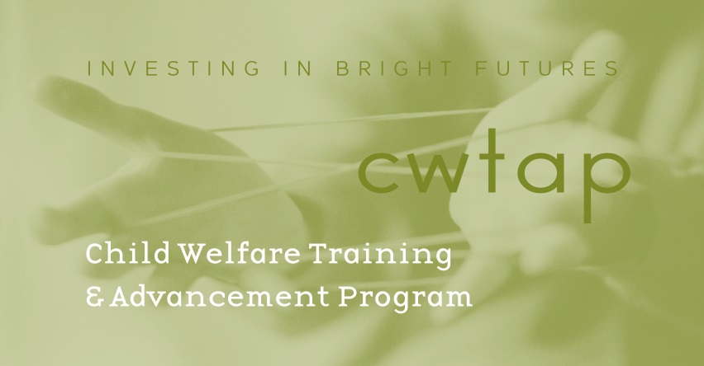

LETTER OF REFERENCE

______________________________________________________________________________

Name of Applicant

______________________________________________________________________________

Name of Person Providing This Reference and Relationship to the Applicant

This letter of reference is for the Child Welfare Training and Advancement Program (CWTAP).

For the purposes of helping determine this applicant’s suitability for the CWTAP, please discuss the following:

1) The applicant’s experience working with children and families (including volunteer and paid/unpaid internships).
2) The applicant’s experience with and capacity for culturally competent practice with diverse individuals and families.
3) The applicant’s commitment and potential contribution to the field of working with families and children at risk.

***PLEASE EMAIL THIS COVERSHEET AND YOUR LETTER TO
Program Operations Specialist- Susan Welk susanw22@uw.edu.***

