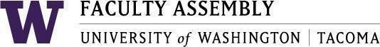

Agenda
Faculty Affairs Committee Meeting
September 22, 2025 / 12:30pm-1:20 p.m.
Zoom

- Recording Permissions/Consent [2 mins]
- Introductions: Fun Fact or Recent Accomplishment [5-7 mins]
- Faculty Affairs Charge: Review and Recommendations [10-15 mins]
- Priorities for 2025-2026: Discussion [5-10 mins]
- Workload Equity Reporting Update: Ken [5-10 mins]
- Next Steps: Discussion [5-10 mins]

Join Zoom Meeting
https://washington.zoom.us/j/93321348266
Meeting ID: 933 2134 8266
Dial by your location
• +1 253 215 8782 US (Tacoma)
• +1 206 337 9723 US (Seattle)

