Executive Report
Summary and Analysis of AP Survey Plan Data
December 2024

Audience(s):
APCC
EFC’s/Unit Curriculum Committees
EC
Academic Affairs
Council of Deans
Chancellor’s Cabinet
Regents

Programs responding:
34 total
24 Undergraduate –10 Graduate
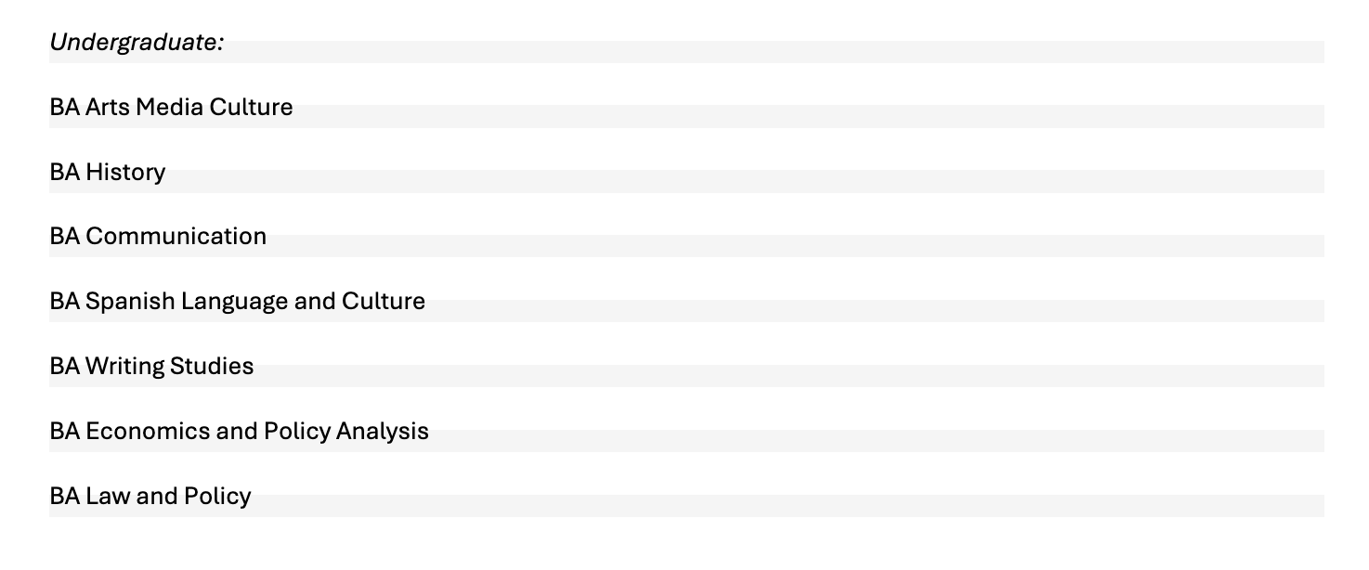
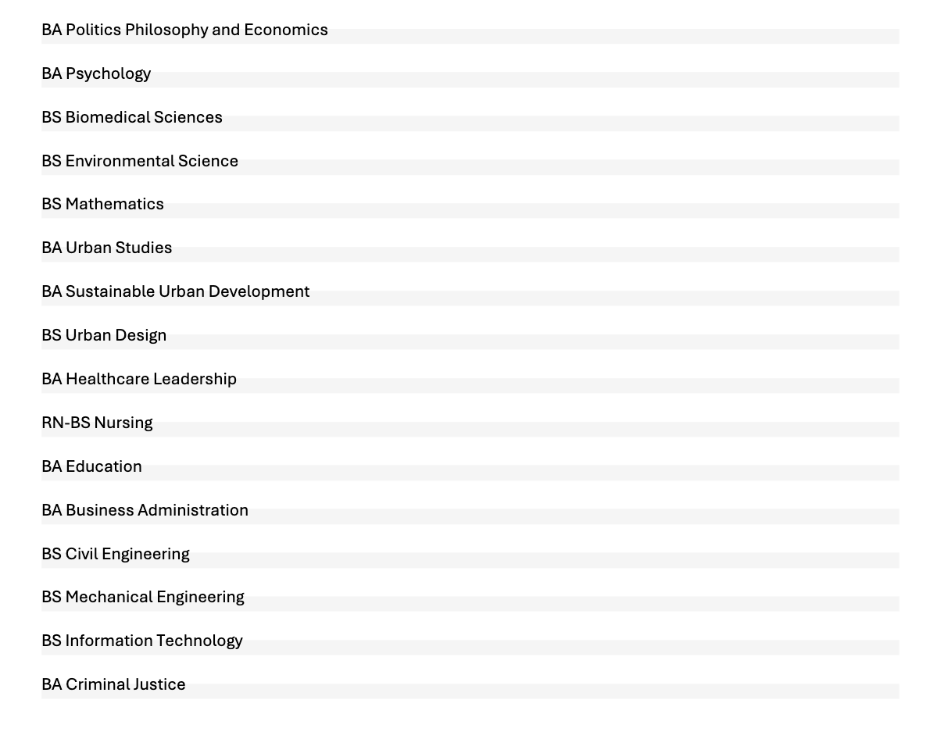
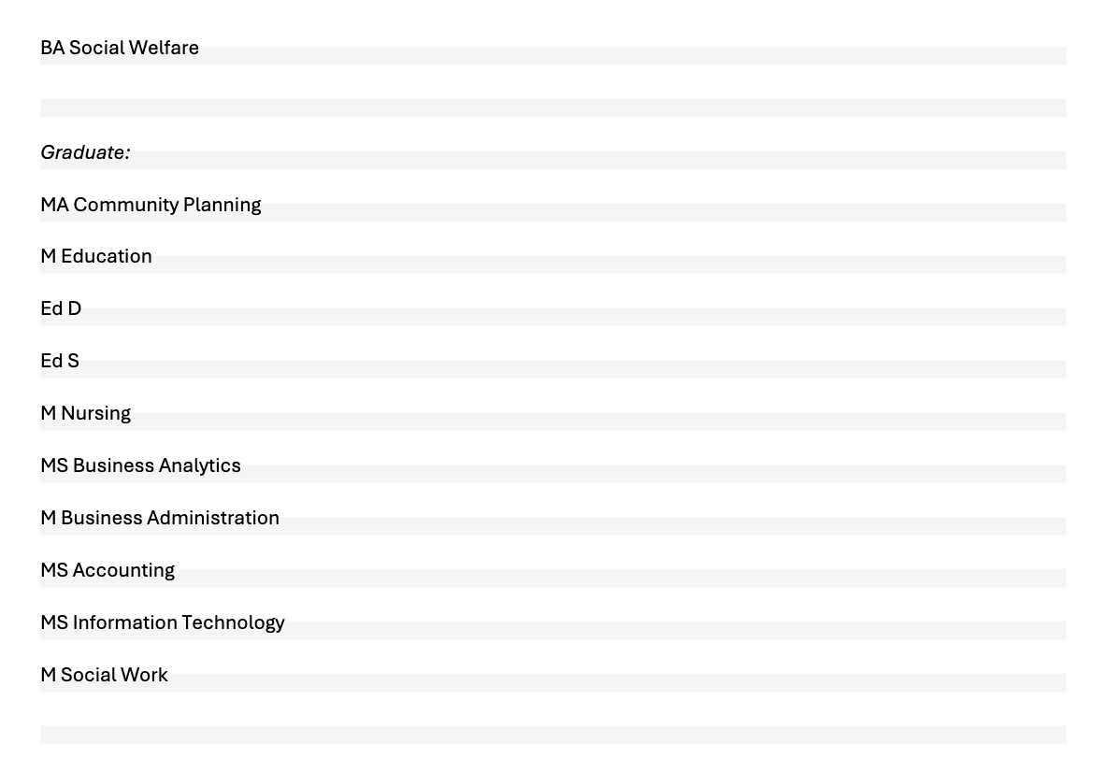
Response was solid but not comprehensive.
It is stronger than expected. There are inconsistencies in the programs represented due to the positionality of respondents, the timing and difficulty of soliciting input across entire units, and the challenges of reporting for shared programs (e.g. MCL or similar).
The responses include data and rationales for programs in planning and development, providing a helpful snapshot that is acknowledged and referenced as possible in this summary.
Responses are required for programs proposing changes in the current and upcoming cycle of APCC/UWCC review. The effective and widely communicated nature of this requirement likely accounts for the strength of responses, which are summarized below.

AP Survey categories:
Categories and questions were created with the 2018 Academic Plan. The 2023 revision added a framework for their evaluation; these are in Appendices A-B of the UWT Academic Planning Policy.
The survey was designed to be general enough not to discourage participation, while eliciting baseline information for sharing and building understanding among program leaders. The responses provide helpful insights on each of the eight categories, including existing innovation and investment, aspirational areas of growth, and service contributions to the campus and community.

Internal and Community Demand
- 97% of respondents engage with diverse community partners to determine demand and needs
- 100% communicate about the major or program to current or potential students, including their needs, interests, and post-graduation opportunities
- 87% interact or interface with community technical colleges (CTCs) or high schools

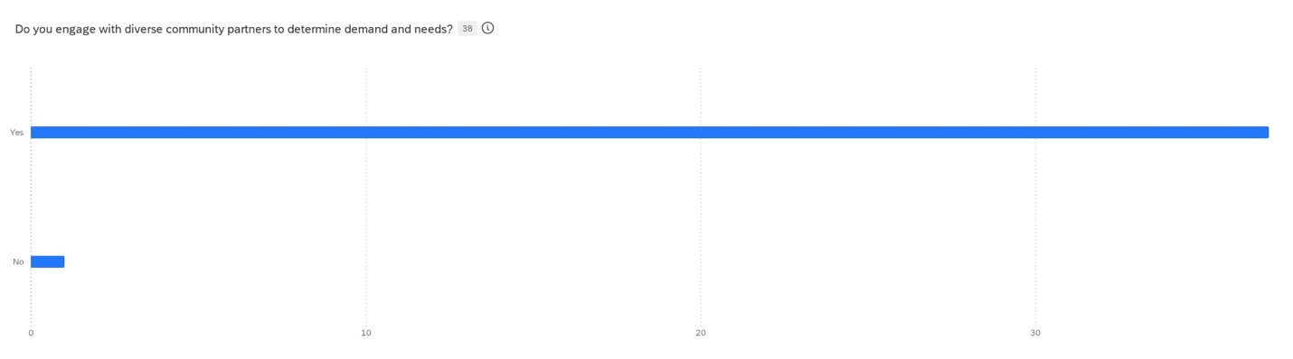“Do you engage with diverse community partners to determine demand and needs?”
Programs engage a range of different constituencies to develop curriculum and refine offerings. Connecting to area institutions where students are seeking further education opportunities is a widespread practice. More specific information about how programs are conducting this engagement and with what partners could be useful for all units, to learn from and reinforce one another, and save time and energy staying on-message and effective in relation to our local and regional partners.

Program Quality
- 50% of programs are professionally accredited, 50% are not (through the professional accreditation boards of specific disciplines and fields)
- [NB: all programs are accredited by the University of Washington, and through the accredited status of the UW Tacoma campus]
- Slightly more than half of programs have multiple tracks or pathways (53%); of these, 81% support adequate enrollment and 88% consider their pathways “clear and transparent to students”
- Just less than half of programs currently offer a minor (47%); in addition, 44% identify the possibility of a new minor
- There are hybrid/online options for 92% of programs. Rationales include student access, meeting needs for non-traditional students, and providing flexible options for electives and courses with multiple sections
- Potential plans for invigoration based on student demographics:
  - Strengthened internship programs
  - Formalization of hybrid pathways
  - Training in multilingual approaches and intercultural competencies
  - More experiential and active-learning classroom pedagogy
  - Paid research opportunities, expanded financial aid for part-time students, and on-campus childcare
  - Longer lab sessions to ensure competitive job placement
  - Course schedules that respond to needs of working students
  - Increased focus on practical skills and technical training to aid job-placement success and professional efficacy
  - Learning community “clubs” to build student networks, develop disciplinary confidence and enjoyment
  - Intentionally incorporating diversity content in required courses
  - Accelerated degree completion options (1-yr Masters)
  - Direct, proactive engagement with regional partners and employers
  - Smoothing direct admit from undergraduate to graduate programs
  - Improved engagement with area high schools and CTC’s
  - Research funding and training support for underrepresented groups
  - Doctoral programs to support practitioners and professional impact
  - Deepen surveys of current, potential, and future students
  - Lab spaces for simulation, clinical training, and skills development

- 86% see opportunities to optimize offerings, based on current course enrollments
- Almost all programs assess student learning (97%); 72% track post-graduation pathways, and 83% have made program adaptations based on feedback and assessment data
- 3/4 of programs report course caps appropriate to curricular goals (75%). 56% identify places where courses could be bigger or smaller, generally at the lower and more advanced levels, respectively. 88% say courses are filling, and all programs say that students can take required classes in a timely manner to move towards graduation.
- 2/3 of programs support students in undergraduate general education, in the areas of inquiry, writing, or diversity courses; and beyond the major, or pre-major students.
- All programs provide support beyond graduation, including invitations to campus events, alumni networking, and maintenance of online groups and social media professional networks (eg LinkedIn)
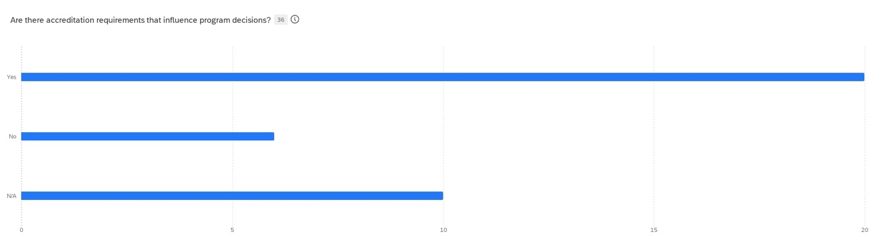“Are there accreditation requirements that influence program decisions?
Yes – No – N/A

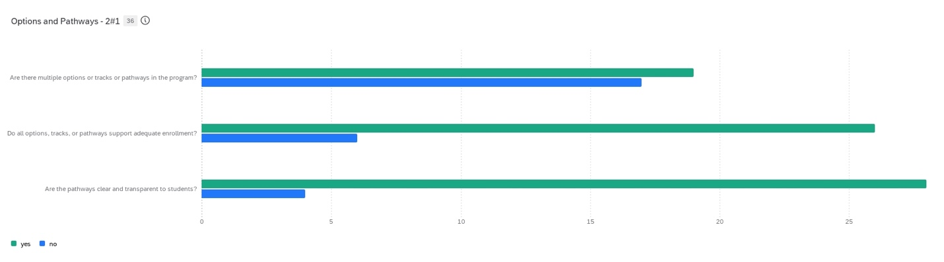“Are there multiple options or tracks or pathways in the program?”
“Do all options, tracks, or pathways support adequate enrollment?”
“Are the pathways clear and transparent to students?”
Green = Yes
Blue = No

All programs are actively developing and improving accessible pathways for delivery of academic programs. Sharing more of these efforts and investments, and identifying areas of targeted success and potential support, can build efficiencies and strengthen the collective learning culture.

Human, Physical, and Technical Resources
- 77% of programs recognize opportunities to reassess available resources, 73% have resource needs that aren’t met, and 68% see opportunities to collaborate with other programs to optimize resources.
- Most programs do some form of marketing and recruitment. These include job fairs, professional networks, social media presence, outreach and introductory workshops at campus recruitment events; as well as program brochures, and the circulation of online and printed materials.
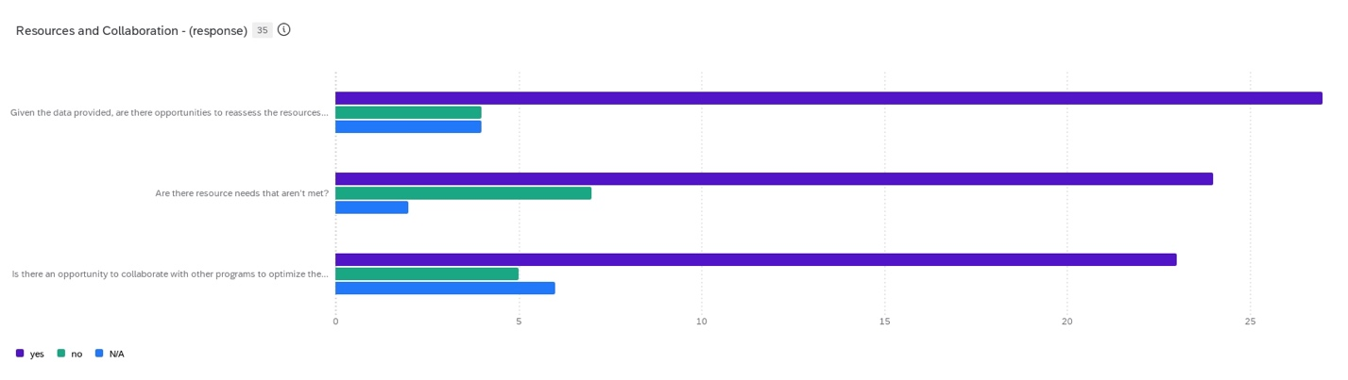Opportunities to reassess?
Resource needs that aren’t met?
Opportunity to collaborate with other programs to optimize the resources available?
Purple = Yes

Programs seeking additional resources recognize that added collaboration could put this within reach and add appeal for marketing and recruitment purposes. Barriers to program collaboration should be evaluated in this light, with an emphasis on the potential upside to sharing of resources and increasing admissions yield for the campus as a whole.

Future Potential for the Program
- 85% of programs see opportunities for attracting working professionals or providing professional development, and 15% see this as a possibility
- 47% of programs currently offer minors, and 44% see opportunities to do so
- A variety of options could expand student pathways for content delivery, including
  - New minors (eg Web Design, Video Production, Digital Media);
  - Certificate Programs (eg Restorative Justice, Youth and Justice, Behavioral Health, Neurodiversity; Environmental Modeling, Statistics);
  - Stacked certificates (grad level) and micro-credentials (undergrad level) for targeted training that is legible to employers
  - Curriculum review and new program proposals currently underway (SIAS, SUS, SET, SNHCL) that could produce new or realigned offerings
  - Post-master's coursework for Continuing Education through accredited professional programs;
  - Encouraging students to pursue minors concurrently in other programs, with their own unit’s major/degree program (eg BA in Education with a minor in Latinx Studies or American Indian Studies)
- Some programs currently offer online options; some respondents note the pedagogical unsuitability of doing so. Opportunities for expanded online delivery include:
  - Online professional programs for undergraduate working adults with an AA degree or existing apprenticeship training, who want a bachelor's degree in a specific field
  - Potential for fully online training and certification in discrete, content-based areas (eg grant writing, professional communication) - with appropriate staff support and curriculum development resources
  - Online programs tailored to serve rural students and/or military veterans are an important online learning opportunity to expand our offerings and reach, potentially nationwide
  - Hybrid delivery can support overall access and help sustain diverse student cohorts, without compromising the in-person strength and relational experience that are a competitive advantage for many of our students – and for our campus
- UWT has existing strengths to protect and grow:
  - Disciplinary limits on online viability favor our in-person, small campus setting, for example hands-on evaluations for clinical training and wet lab space for natural scientists
  - Respondents note that market conditions – existing prevalence of fully online options at relatively accessible price points at other, well-established universities - make this an area in which to tread very carefully
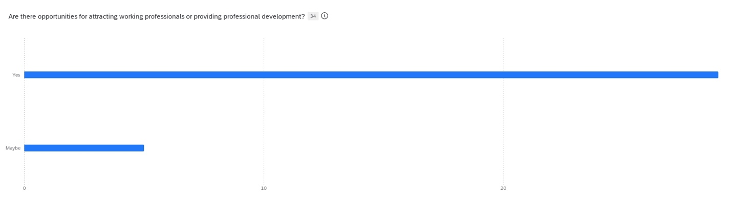“Are there opportunities for attracting working professionals?”
Yes = 85%
Maybe = 15%
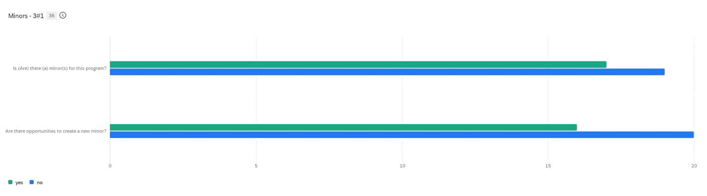Is there a minor?
Are there opportunities to create a new minor?
Yes = Green
No = Blue

Programs are clearly exploring and developing tailored approaches to meet the needs of our students, and further the opportunities and emerging knowledge content areas of their fields. Professional market value, skills training, and intentionality in design and delivery are key themes across the campus.

Student Enrollment, Retention, Well-being, and Engagement
Enrollment Strategies shared and implemented include:
- Advising – engaging early, regularly meeting, tracking the DARS process
- Campus Events – information sessions, open houses, admissions visits
- Community Spaces – outreach through professional partnerships, other higher education and secondary education settings
- Program Pathways – clarifying and modeling for students what a multi-term, multi-year pathway might look like
- Nurturing Pivot Points – teaching in the Core to activate program knowledge; smoothing equivalency requirements to recognize and value prior investment
Only 34% of respondents say that they have adequate staff to support enrollment. One unit (SOE) has an existing Student Enrollment Management (SEM) plan – other units note that a campus-wide SEM template, resources, activities, and support would be welcome.
Student focused mechanisms refer first and foremost to legible degree pathways where program learning outcomes (PLO’s) and availability of needed class sequences are made explicit and clear. Academic clarity thus values students as independent learners and critical thinkers, empowers them to make sound judgments with often limited time and resources, and challenges them to consider trade-offs and seek informed guidance, to build confidence and success in their educational experience. Clear program pathways also challenge faculty and staff to communicate with one another efficiently and effectively, delivering well formulated, consistent, sustainable, and transparent degree options for our students. This can go a long way in improving student engagement and wellbeing, strengthening enrollment and retention at the programmatic core of educational experience.
With clear and consistent degree pathways, various enrichment and support mechanisms can contribute to enjoyment and success within programs and across campus units. These include:
- Academic assistance – faculty mentoring and guided research; campus wide resources that are enlisted to further program and course learning outcomes, such as Library Services and Subject Librarians; the Teaching and Learning Center; IT and Canvas support; and partnerships with affinity groups on-campus (eg Center for Equity and Inclusion, Office of Indigenous Engagement) as well as through the surrounding community (eg class speakers and seminars; community-engaged learning partnerships).
- Student organizations – RSO's with faculty advisors such as the Pre-Law Society, Civitas, Giving Garden, Psych Club, Muslim Student Association, Progressive Student Association, Criminal Justice League and others.
- HIPs – High Impact Practices within the classroom and related to course organization and program learning are shown to heighten student engagement and learning and improve student performance. https://www.aacu.org/trending-topics/high-impact
Rates of participation for the following HIPs:
  - Independent research 69%
  - Global learning 60%
  - Community-engaged Learning (CEL) 86%
  - Learning Communities 49%
  - Internships 71%
- Other HIPs noted include writing-intensive classes; capstone projects; common intellectual experiences; field trips; recognition of excellence in student work
- 53% of programs offer Study Abroad support, from stand-alone courses and trips to engaged alignment with programs on offer through other universities and UW units. *There may have been some inconsistencies in the responses to this question, as qualitative and quantitative responses indicated interpretive discrepancies on what it means to “offer Study Abroad programs”
- 59% of programs have scaffolded Internships throughout their curriculum. Delivery models vary and indicate continuous learning and adaptation across units, with some desire for campus best-practice guidance and support mechanisms.
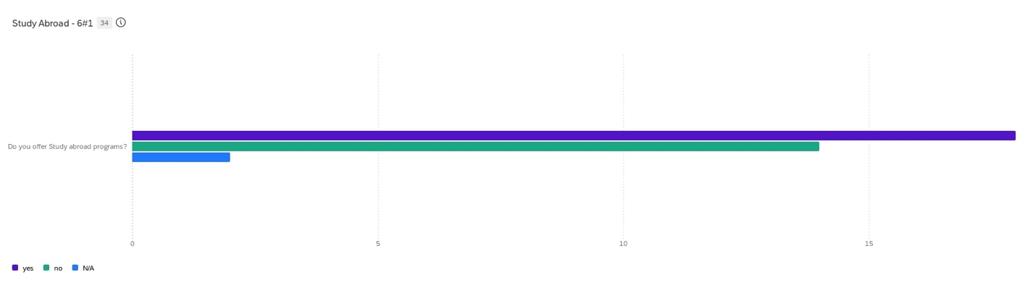“Do you offer Study Abroad programs?”
Yes = Purple
No = Green
N/A = Blue

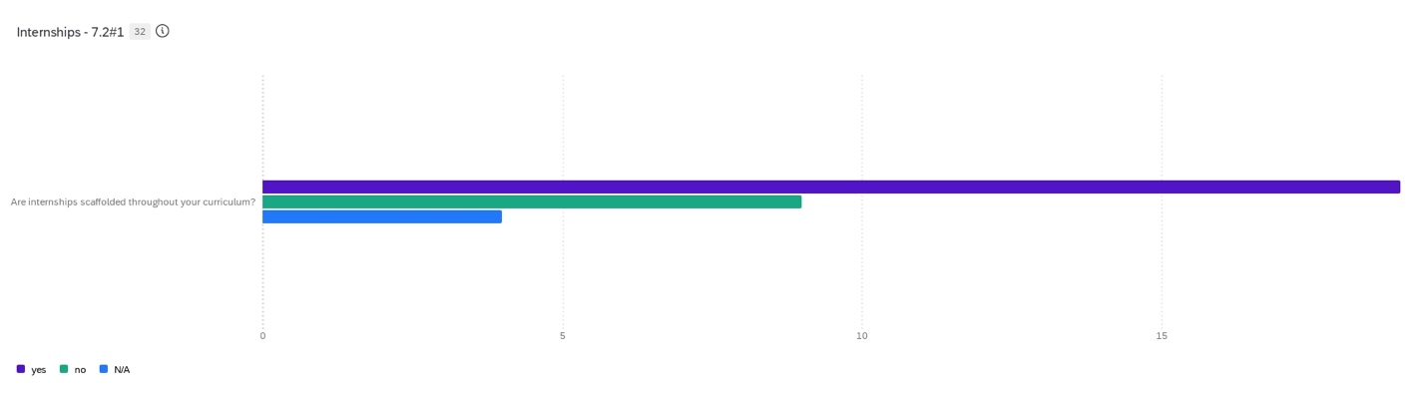“Are internships scaffolded throughout your curriculum?”
Yes = Purple
No = Green
N/A = Blue

There is opportunity for units and programs to continue to learn from one another in this area of clarifying, delivering, and supporting Student Learning Outcomes (SLO’s). HIPs activated and aligned around coherent curricular pathways provide an essential first step in the provision of enrichment opportunities for our students.

Faculty and Staff Recruitment and Retention
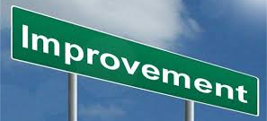
Responses in this section cluster around three distinct stages of employment activity in UW academic units: Search, Onboarding, and Professional Development.
- Search: Committee composition; search process training for committee members; development of inclusive, intentional, and accurate job description and advertisement; review and use of clear evaluation criteria,
- Onboarding: Orientation and clarity of expectations; creating a welcoming environment; providing safe and direct opportunities for clarifying questions; showing recognition and skill in support of diverse staff and faculty needs
- Professional development: continuous improvement in formalization of practices as units grow and diversify; structured time and resources for career development areas that are essential for professional success (eg research support for faculty, technical and management skills known to be essential for different jobs and roles)
- Investment in DEI activities can be woven into the basic mechanics of employment; to do so, objectives and activities of each stage need to be clearly established, ahead of assumptions about positionality, bias, cultural conditioning as the area of intervention: make clear to potential, new, and longtime employees the professional expectations of all positions, as a first step before taking on longer term cultural approaches which require trust and respect that are established through mutual professional work commitments.
- Programs and units have established a variety of internal representative DEI bodies, including such groups as: Dean’s Diversity Advisory Council; Race, Equity & Justice Committee; School Diversity Committee; Equity & Inclusion Committee; Diversity Workgroup; Justice Equity Diversity & Inclusion (JEDI) Council
- Programs liaise with campus, university, and professional associations beyond the unit, to leverage training, resources, and best practices to improve culture and environmental mechanisms for faculty and staff, such as: UWT Center for Equity and Inclusion, AHR and AA at the campus and university level, professional societies for women, people of color, LGBTQIA+ identifying colleagues.
- Programs use existing, emerging, and aspirational trend data for student enrollment, to devise hiring plans to match and meet the needs of the student body. Positionality and experience impact faculty and staff ability to engage students effectively, and deliver learning outcomes of individual programs – thus, hiring and retention in some units has kept pace with best available research showing that a diverse and inclusive professional environment is highly effective in serving students across the demographic spectrum of the state (and beyond).
- Mechanisms for support and retention include: DEI training for all faculty and staff; strategic engagement of national and regional expert practitioners to improve skills and understanding in a collaborative and supportive environment; creation and sustaining of formal mentorship programs; partnering with UW Advance on retention offers.
Program leaders note the utility of clear functional practices and clarity in setting and executing on professional expectations, as a first and essential step in enabling and empowering transformational cultural learning within units, to create working environments conducive to the success of all UW employees.

School or Division Level
Investments to strengthen unit-level climate include:
- Commitment to democratic practice and decision-making;
- transparency in work assignments, compensation, provision of opportunities;
- robust commitment to, and attendance at social events;
- intentional retreats and collaborative planning that include all staff and faculty, and taking proactive responsibility for any exclusion that occurs, whether intentional or not;
- published materials, meeting schedules, agendas, minutes, with sufficient lead time for all staff and faculty to anticipate discussions and decisions, and contribute to conversations in an informed and helpful manner;
- Accessibility and inclusion of all faculty and staff in communication platforms, scheduling norms/software/expectations (eg calendar and messaging systems), awareness of committee meetings and their timing – whether individual staff and faculty members need to be present, or not, as a matter of building a culture of trust, respect, clarity, routine, known decision points, professionalism;
- Shifting all-unit meetings from 100% ‘informational’ (Freirian banking or ‘talking at’) to 65-85% interactive work/discussion;
- Establishing a framework for leadership and unit priorities, to orient and aid evaluation of necessarily conflict-prone decisions, enabling understanding, sharing, discussion, and clarification of choices that are/not made, whether popular or not;
- Recognize individuality and unique contributions of different faculty and staff members, across a variety of genres, areas of scholarship, modes and strengths of teaching, forms of community engagement, and public intellectual work.
Support for Scholarship at the unit level includes:
- Course release policy – providing programmatic support for externally-funded course releases at a standard level across the unit (eg up to 3 per year for TT faculty, with appropriate sources for PTL replacement if necessary); making internal funds available for course releases in a transparent and timely manner for course development, service, leadership, and mentoring commitments (for instance)
- Policy on Distribution of Indirects – providing incentives for faculty to claim up to 50% of grant-generated indirect revenues, to guide individual project and lab-specific investments on primary research – remainder to school-wide stipends, writing retreats, scholarship productivity (for instance); establishing policy on program indirects (cost transfer indirects) to support professional development, curriculum development, instructional training.
- Professional Development Funds (PDF) - Provision of baseline annual support for research travel, fieldwork, and supplies; conferences, project development, dissemination of research; pedagogical and skills development
- Time and venues for the development of research – standard third-year research leave (TT, one quarter); eligibility and encouragement of regular sabbatical leave (requires planning and unit-level approval); formal and informal unit-level sharing of in-process research, eg seminar talks, brown-bags, research working groups
- UW funding guidance – highlighting, encouraging, and advising on creating successful applications for UW-based funding, and creating connections to UWT and UW-wide research office and research groups
- Administrative support – project-specific guidance for hiring and mentoring UG and grad research assistants; documenting and meeting grant-mandated reporting requirements; tracking and training on grant management tasks, eg budgets (proposed and approved/allocated), hiring, travel, human subjects review and renewals, space allocation
94% of programs report collaboration within the unit.
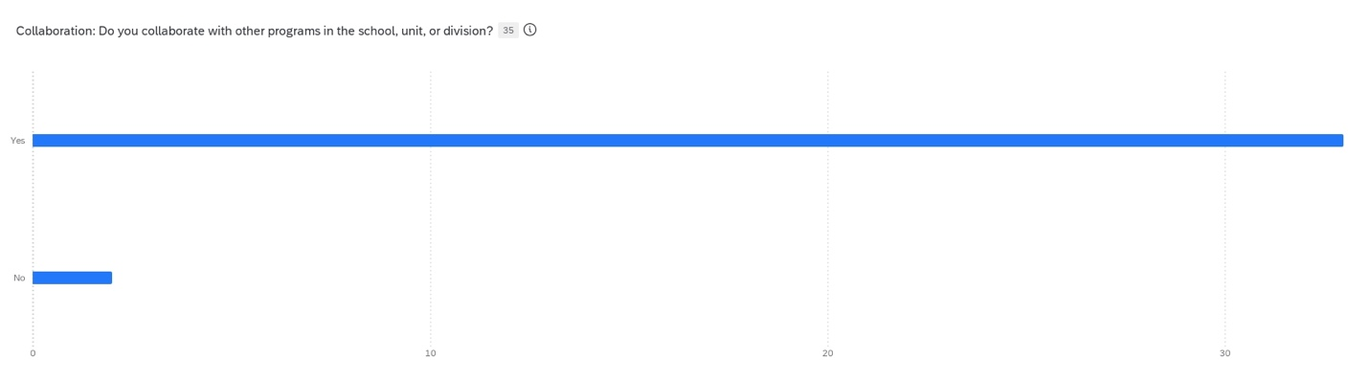“Do you collaborate with other programs in the school, unit, or division?”
Yes = 94%
No = 4%

Opportunities for resource sharing are executed more easily within the unit. This may be for reasons of proximity, familiarity, and/or routinized budgetary practices (eg FTE and headcount accrue to specific units and have resourcing implications). While collaboration and partnership can be established across units, this requires intentional and strategic structural commitment. The underlying relationship between partners has been explored through:
- Co-teaching and shared course development. While cumbersome, this exercise can provide an opportunity for faculty to explore areas of potential interest, evaluate shared bibliography, and identify mutual or complementary expertise with a short-term, instructional, familiar framework to guide collaborative interaction.
- Co-authored publications. Beneficial to all parties, a distinct, peer-reviewed research output can enable identification and development of shared interests.
- Interdisciplinary and cross-disciplinary centers. Existing outside the boundaries of individual units, and bringing together members of different fields and disciplines, these can create a “value-add” for all participants that sustain themselves with unique and purpose-directed funding, to support existing units and amplify the reach and impact of programs, increasing and reinforcing rather than trading or threatening budgetary lines of institutional support.

The appeal of sharing resources for the development of degree programs and funded research is clear. To surmount the well-known institutional barriers, targeted support for faculty seeking to test and evaluate potential partnerships could be a high ROI practice for campus administrators to prioritize.

Interdisciplinary Exploration
Opportunities for development of interdisciplinary initiatives cluster in areas of teaching, applied research, and community engagement.
Teaching
Existing programs take advantage of the relatively small and agile nature of our campus, such as Global Honors. Tensions emerge; however, when interests and take-away are made clear for all students and their home units, can be resolved to mutual benefit.
Interdisciplinary and collaborative training programs (such as cybersecurity) require investment in developing balanced curricula, devising labor and compensation models that are sustainable, and identifying funding sources to support shared administrative needs.
Applied research
Centers and funded research projects that sustain commitment across units tend to have a very specific and comprehensible focus on a topic area or noted, highlighted, and high-need area of regional development dynamics (eg the Center for Urban Waters, the Labor Solidarity Project, and other initiatives that draw in and enable collaboration among a variety of research and professional, practice-based communities)
In addition to foregrounding areas of important interest and civic need in our society and shared environment, applied research with external funding carries with it the benefits of supporting student research, building campus reputation, and enabling requisite staff support (albeit on ‘soft money’ sources, requiring ongoing renewal).
Community engagement
Direct engagement with local non-profits, government agencies, and business groups helps to yield practical educational outcomes, and pragmatic, evidence-based, focused research designs that further faculty, staff, student, and alumni careers.
In some units, this engagement is engendered by professional accreditation and clinical training needs. Partnership models increasingly show that innovative growth in original, applied research and deeply rooted, highly beneficial experiential learning can continue to distinguish the UWT campus from our larger, longer established, and more traditional peers in higher education.
This could be an important area for campus leadership to strategically prioritize, identify and quantify/document the rationales for making specific investments. Data showing areas of opportunity, emerging needs, and existing abilities and strengths of the UWT campus will help to make optimal, responsible use of public resources in the ongoing development of our campus.

Conclusion
Based on our initial survey responses, the first Academic Planning cycle has yielded the following themes and recommendations.
- Academic programs working to clarify degree pathways further the first, essential building block for all enrichment, inclusion, collaboration, evaluation, and engagement activities related to the fundamental purpose of the university, and the urban-serving mission of this campus. Clear, well operationalized, legible, and accessible curricula are the basis on which all other activities of academic planning rely. Strong degree pathways support the invigoration and growth envisioned by the Academic Plan.
- Enrichment practices and academic support to serve student learning outcomes (SLO’s) drive successful utilization. SLO’s must be established and clear for these investments to be effective. See #1 above. DEI investments and practices can generate effective production of this relationship: reliably delivering on program-based SLO’s, so that students move efficiently and successfully through their degrees, graduating with a positive and well-prepared knowledge base to begin careers, and contribute to the health, prosperity, and vitality of the region and state (and beyond).
- Clear expectations for all academic positions (faculty, staff, and students) contribute to a positive and productive climate. Job description, organization chart, search practices, regular review and feedback, and compensation practices produce and sustain basic understanding of professional roles and responsibilities, and how these fit within and further the purposes of the unit, program, campus, and university. DEI supports should reinforce and respond to this clarity in professional efficacy, improving and strengthening the ability of faculty and staff to excel in our work, based on this shared understanding.
- Seeding first-step interdisciplinary collaboration (co-teaching, co-writing) can be an effective way to grow our funded research profile, as well as self-sustaining cross-unit centers to reinforce and grow existing strengths, and support capacity and career growth for students, staff, and faculty.
- Assessment practices using relevant data (defined at the program, campus, and regional level) enable us to track and understand how we are performing on the delivery of SLO’s. A culture of curiosity and continuous learning empowers us to become increasingly proficient at the skilled work that we do, which social science researchers tell us can be a key predictor of happiness (vague concept though that can be). The wellbeing of students, staff, and faculty is enabled by establishing and nurturing conditions where all members of the academic community become skilled contributors to the endeavors of that place (ie the overall project of knowledge production).

The first program survey of the UWT Academic Planning Policy yields helpful understanding of areas of substantial accomplishment, as well as highlighting places of shared opportunity. By moving forward on campus growth initiatives and program supports that amplify mutual benefits across units, UW Tacoma will continue to actualize its potential as an urban-serving, innovative, and impactful public research university.
Respectfully drafted and submitted,
Anne Taufen, Professor of Urban Studies
Chair, Faculty Assembly (2024-2025)
Member, FA Academic Planning Task Force (2022-2023)

