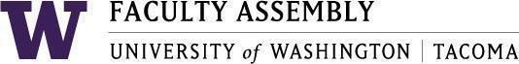

Agenda
Faculty Affairs Committee Meeting
November 17, 2025 / 12:30pm-1:20 p.m.
Zoom

- Recording Permissions/Consent, Approval of Minutes [2 mins]
- NTTFF Update: Jeong-Ah [2-5 mins]
- Research Advisory Council Update: Ken [2 mins]
- Workload Equity Reporting Update: Ken [2-5 mins]
- Budget Subcommittee Update/Discussion: Ken and Ehsan [5-10 mins]
- Race & Equity Subcommittee Update: Julia and Morgan[5-10 mins]
- AI Survey Update/Discussion: Ken, Gregory and Eyhab [5-10 mins]

Join Zoom Meeting
https://washington.zoom.us/j/93321348266
Meeting ID: 933 2134 8266
Dial by your location
• +1 253 215 8782 US (Tacoma)
• +1 206 337 9723 US (Seattle)

