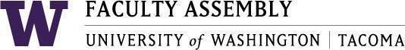

Agenda
Faculty Affairs Committee Meeting
December 8, 2025 / 12:30pm-1:20 p.m.
Zoom

- Recording Permissions/Consent, Approval of Minutes [2 mins]
- NTTFF Update: Jeong-Ah [2-5 mins]
- Workload Equity Reporting Update: Ken [2-5 mins]
- RAC Language Update: Ken [2 mins]
- Budget Subcommittee Update/Discussion: Ken and Ehsan [2-5 mins]
- Feedback on AI Survey: Discussion [5-10 mins]
- Feedback on International Faculty Report: Discussion [5-10 mins]
- UWT Diversity Task Force: Julia [5-10 mins]
- Around the Table: Discussion [2-5 mins]

Join Zoom Meeting
https://washington.zoom.us/j/93321348266
Meeting ID: 933 2134 8266
Dial by your location
• +1 253 215 8782 US (Tacoma)
• +1 206 337 9723 US (Seattle)

