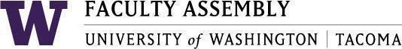

Agenda
Faculty Affairs Committee Meeting
January 12, 2026 / 12:30pm-1:20 p.m.
Zoom

- Recording Permissions/Consent, Approval of Minutes [2 mins]
- RAC Language Presentation and Discussion: Randy Nichols [10-15 mins]
- NTTFF Update: Jeong-Ah [2-5 mins]
- Workload Equity Progress Report Update: Ken [2-5 mins]
- Feedback on AI Discussion Instrument: Discussion [10-15 mins]
- UWT Diversity Task Force: Julia [5-10 mins]
- Around the Table: Discussion [2-5 mins]

Join Zoom Meeting
https://washington.zoom.us/j/93321348266
Meeting ID: 933 2134 8266
Dial by your location
• +1 253 215 8782 US (Tacoma)
• +1 206 337 9723 US (Seattle)

