Approval Step for Course Fee Form
An approval step requires a user to review and take the "Approve" action. The workflow cannot continue until the step is approved.
In the Course Fee Form, school administrators will decide whether the course fee request is approved or denied.

Instructions
- If you have a course fee request to approve, you will receive an email; the screenshot below shows an example of this email. Click the purple Begin Review button in the email notification to see the details of the course fee request.

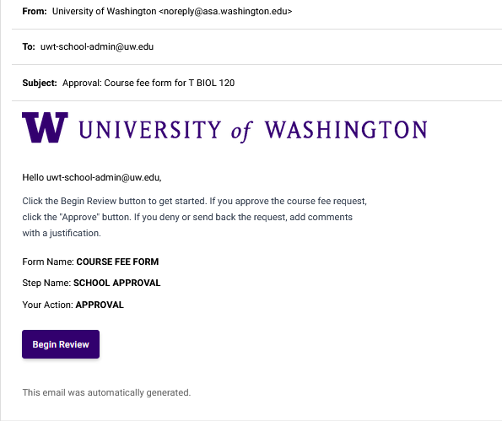

- After you’ve reviewed the details of the request, you can enter comments about the request, your signature, and the date signed. The screenshot below shows this part of the form.
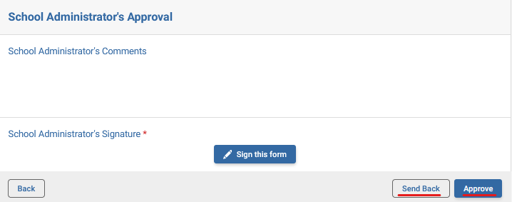

- Click Approve to advance the request through the Workflow. The request and your comments will be reviewed by staff in the Finance Office, Office of the Registrar, Academic Affairs Planning and Budget, and Finance, Planning, and Budget at UW (Seattle) if the amount is greater than 50% or course fee increases in excess of 10%.

- If it's not ready for you to take the Approval, click Send Back to return it to the person who initiated the request. The screenshot below shows the Send Back Option pop-up window.
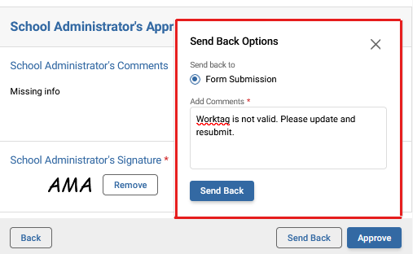

- The requestor will receive an email notification with the comments that you entered in the Send Back Options pop-up window. The screenshot below shows an example of the email notification.
