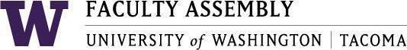

Agenda
Faculty Affairs Committee Meeting
April 13, 2026 / 12:30pm-1:20 p.m.
Zoom

- Recording Permissions/Consent, Approval of Minutes [2 mins]
- Spring Check-In: What makes you optimistic/gives you hope [5-10 mis]
- NTTFF Update: Jeong-Ah [2-5 mins]
- RAC Update: Ken [2-5 mins]
- Budget Advisory and Advocacy Council Update: Ken [5-10 mins]
- International Scholars Report Follow Up: Julia and Morgan [5-10 mins]
- AI Instrument Update: Ken, Eyhab and Gregory [2-5 mins]
- Around the Table: Discussion [2-5 mins]

Join Zoom Meeting
https://washington.zoom.us/j/93321348266
Meeting ID: 933 2134 8266
Dial by your location
• +1 253 215 8782 US (Tacoma)
• +1 206 337 9723 US (Seattle)

